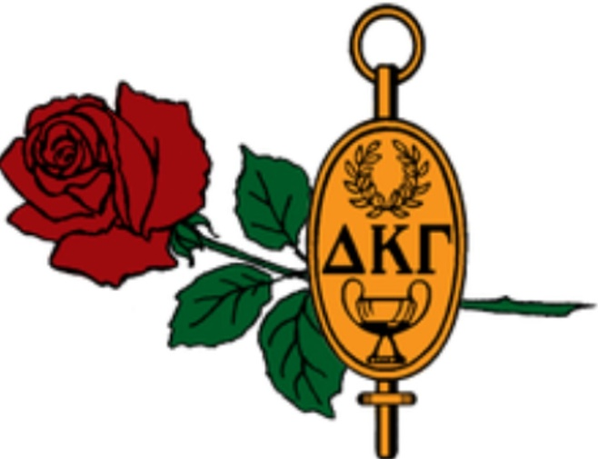DELTA ROSE
OUTSTANDING ACHIEVEMENT AWARD
Cindy Frazer

Presented on this day, September 17, 2022, for
dedication & commitment to Alpha Chi Nevada State.

Cheryl A. Anderson
Alpha Chi Nevada State President
2019-2023

